**M1 - Describe the potential impact of emerging network technologies**

**Introduction**

In this assignment, I will be discussing the potential impact of emerging network technologies. It will include *enhanced capabilities, faster*, **greater storage capacity**, *and improved control; new work methods*: **mobile working, home working**, *web centric applications and ease of use.*

**Enhanced capabilities**

The potential impact of emerging network technologies is that can make the communication between two networks much faster. The impact is huge. If two computers are communicating with each other, it could be either slow or fast. The potential impact of emerging technologies could make it faster or slower. It could be slow because the far you are to the connection, it would be slow. If you were closer to the connection, it would work faster. The image below shows the enhanced capabilities that the latest computers can do. You can change the language to the language that you normally speak.

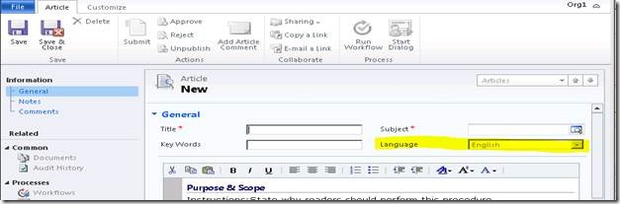

**Faster**

The impact could be to make it faster. This is because fewer cables, it would work faster e.g. mobile working. If the user is using his laptop or mobile phone to work on, it may be faster because both devices are portable. Everybody wants there network to be fast. It is how they process and use the information.

|  |
| --- |
| GOOD |
| Better connection |
| Work faster |
| Multi-tasking |
| Open/Close the laptop/computer |
| Trying to browse something |
| Not many errors |

**Web centric application**

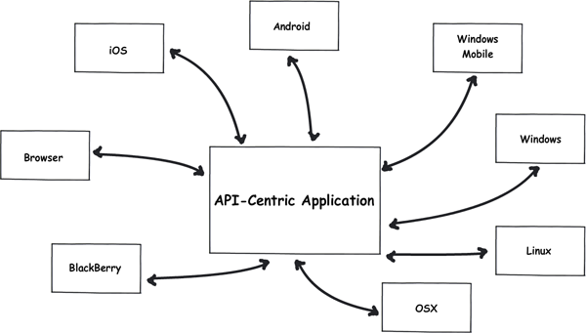Web centric applications are programs that enables users to have access to the specific program to use anywhere. For example, in LSC, we have Moodle that enables us to log in at home. These are web centric applications. A non-web centric application like ELIP does not allow us to log in at home. This is another example. The impact of this is that users can do their work at home. Any teacher that says to go home and work. Students will refer to Moodle for help. This is a big boost by doing the work fast and on time within the deadline set by the teachers.

REMEMBER, THIS IS AN APPLICATION.

**Ease of use**

It says it in its name, ‘ease of use’. The potential impact that this can do is that new users can find the easier way to do anything. For example, if you compare Windows XP to Windows 8, they are many changes that they have done to make things simpler. Making everything easy is the fundamental part of using the computer e.g. writing a letter. All you can do is send an email; it would be simpler and easier than waiting for the written letter to get to its destination.

**Greater storage capacity**

Greater storage capacity means more data can be stored. The more storage capacity you have, the more data the user can store. The user can store anything e.g. document, files, college work, images. Any sort of work that can be stored. The impact of having greater storage capacity enables you to do all of the advantages that is said below.

|  |  |
| --- | --- |
| GOOD | BAD |
| Store more data | Unused may go to waste |
| Data can be stored on any drive | Expensive |
| The maximum is a lot. This means the user can save as much documents as he wishes | Limited space – if the user has many documents to save |
| Faster | The data might get lost |
| You can save a lot of data on the greater storage capacity | The data might be corrupted. This means he will need to save what he has on the device |

**Examples**

**USB, Hard drive, Floppy Disk, Dropbox, Knowhow**



**Mobile working with laptops**

Mobile working is going work wherever you can. ‘Mobile’ is freely. This means you can complete any outstanding work wherever you are. The user can use a laptop to complete it. Mobile working is a great advantage. The impact it could have is to complete work faster than others do. During your journey, people can complete work more rather than wasting 30 minutes or 1 hour.

|  |  |
| --- | --- |
| GOOD | BAD |
| More work complete | It takes less than greater storage capacity |
| Faster | Bad connection |
| If any work is due, you can complete it during your journey | Laptop/device can be stolen |
| Anywhere – the work can be complete anywhere using Hotspots and WiFi | Waste of time - if the user doesn’t save his work |
| Use of Internet | The student/employee will not to the standard that they normally do |

**EXAMPLES**

**Laptop, iPad, Any Smartphone, Notebook**



**Home working**

Home working is doing all the stuff that is required by home. The manager through email sets them the work, probably. Home working is a very good impact to have. People have more time to do work with a peaceful environment. People like to complete work nice and carefully.

|  |  |
| --- | --- |
| GOOD | BAD |
| Independent learning | Any practical work, the employee/student cannot do |
| Faster | No help from other colleagues/manager |
| More time to complete work | Boring – it would not be as interesting as it would be in a class |
| No deadlines - has a whole deadline to complete course/work | If the colleague does not understand something, he will need to go to the manager. |
| Peaceful - any student/colleague likes to learn/work in peace, he will get it by home working. | Big distractions e.g. brother |

**EXAMPLES**

 **Any device**